**Atmospheric Interaction: Fronts**

**The Wavetable Project**

Have you ever wondered what weather patterns meteorologists analyze to predict the weather? Well, today we are going to be simulating one of the primary phenomena which are used to predict an incoming storm, devastating winds, or bitter cold.

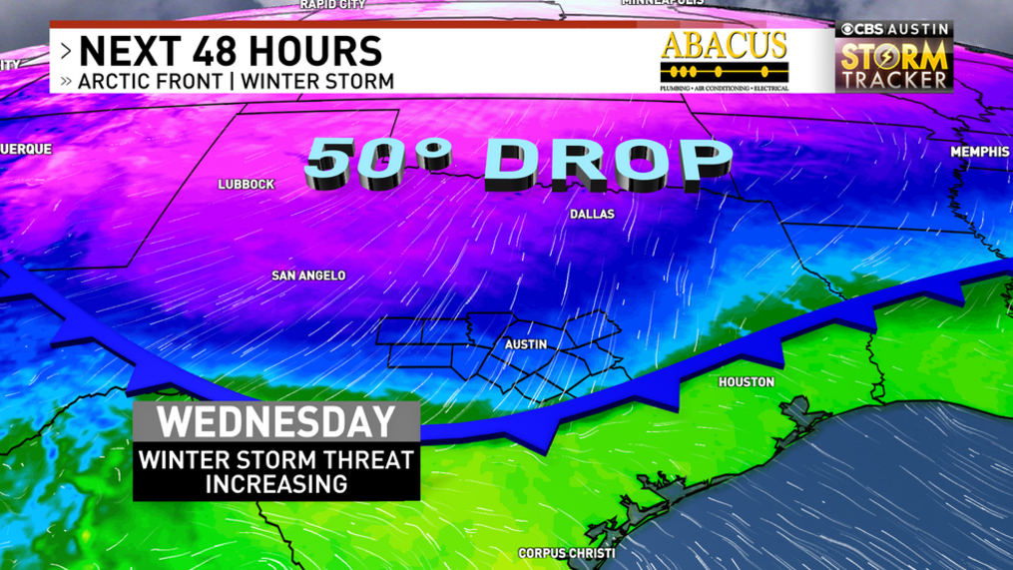**Figure 1.** This weather forecast on CBS Austin shows the movement of a cold front (the blue line with triangles). [8]

**Before you begin, you will need:**

1. Wavetable
   1. With a RECTANGULAR tank
2. 3 jars
   1. Approximately 2-3in diameter x 5+in
3. Food grade dye
4. Hot water
5. Camera or iPhone
6. A computer that can connect to the camera. (Secondary Screen)
7. Cold saltwater
8. Hollow cylinder (A soup can with both ends removed will suffice).

**Safety:**

1. Keep all exposed wires away from the water tank
2. Keep all long hair tied back and away from any spinning parts of the setup
3. **This lab does not utilize the gantry as a means of recording the experiment. Begin the experiment by setting up your recording device pointing towards the tank on a nonrotating surface (ie. not on the spinning platform).**
4. **Create a saltwater solution in a separate container by mixing as much salt into 2 liters of water until it reaches saturation. Add some food coloring of your choice as well.**
5. **Place the hollow cylinder in the middle of the tank, and then proceed to fill it up with your cold, saltwater solution until it is nearly at the top of the cylinder. Then, fill the main tank with plain water until it is about 2 centimeters below the top of the cylinder. Set the rotation of the tank to** set 0.75 **and wait for solid-body rotation to be achieved in the tank.** *Note: set 0.75 might not be the correct rotation rate, depending on the software patch you are using. If it seems really slow, try to set the tank to a rotation rate of ~10 rpm.*

*Please read:*

In this lab, we will aim to give you a working definition and understanding of weather fronts, and their impact on global weather patterns. Weather fronts or, more simply put, fronts are regions where two different masses of air interact. These two masses have unique characteristics, and their properties (such as velocity, temperature, and pressure) have direct impacts on what weather patterns might occur. If conditions allow, resulting patterns can be, large cloud formations, changes in temperature, hurricanes, and tropical storms.

Prior to the discovery of fronts in 1919 by Norwegian and Swedish scientists by the names of Jacob Bjerknes, Vilhelm Bjerknes, and Tor Bergeron, hot air was thought to have been lost to space when it interacted with colder masses of air. But they hypothesized that an air mass would not simply push another into space, but would instead interact in a more comprehensive way—creating turbulence and disturbances. Their so-called fronts were analogies to the battlefronts in the then raging first world war.

There are four categories into which fronts are grouped:

1. Cold Fronts
2. Warm Fronts
3. Stationary Fronts
4. Occluded Fronts

Each of these fronts is usually categorized based on the relative speeds of the two masses of air. **Cold fronts** are scenarios where the colder mass of air is moving towards the warmer air at a higher velocity than it is, and a **Warm front** is the opposite, with the warmer air mass moving towards the colder air at a higher rate of speed. **Stationary fronts** are even simpler, as they are scenarios where neither of the masses is moving fast enough relative to the other to cause a warm or cold front and they both stop moving. Finally, an **Occluded front** is categorized as a scenario when a cold front overtakes a warm front, essentially pushing the warm front upwards from behind.

What do you think the cylinder filled with cold water represents? What type of front do you think we might be trying to simulate here?

|  |
| --- |

1. **Once solid body rotation has been achieved, quickly, and with minimal turbulence, remove the hollow cylinder and let the cold water move into the larger mass of warmer water.**

Sketch what you see from the side-mounted camera.

|  |
| --- |

*Please read:*

**Cold Fronts**

As discussed above, a cold front is when a colder mass of air pushes into another warmer front. More often than not, the cold front will be moving at a speed up to twice the speed of the warmer air. The high density, cold air pushes the lightweight warm air up and usually leaves the region colder, devoid of rain, and sometimes with high altitude clouds like stratocumulus.

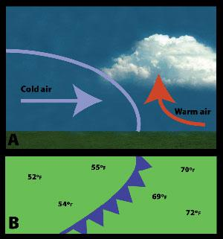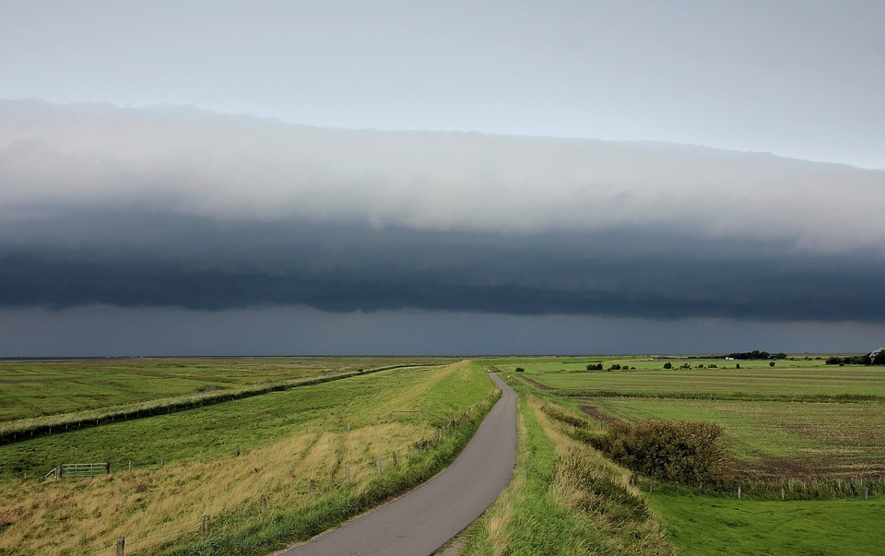

**Figure 2:** A simple diagram showing how a colder mass of air pushes the warmer mass of air above it as it advances. [1] **Figure 3:** A real-life example of a colder front of clouds pushing into a warmer region of the air. [2]

The shape that cold fronts create is outlined in Fig 1, and it is generally shaped like a slightly flattened half circle. This shape is unique to cold fronts, and as we will see later, warm, stationary, and occluded fronts all have different shapes which they form. It forms this shape because the much denser cold air feels little resistance to the hotter air mass through which it is moving. It acts as a blunt force that moves the warmer air out and over itself. Another piece to add about cold fronts, and fronts, in general, is that when the two masses meet there is a build-up of potential energy, and some of that energy will be released in tiny amounts through eddies. These eddies are small and generally insignificant, but they are the product of the Coriolis force and a build-up of energy in both atmospheric and oceanic fronts.

**Warm Fronts**

A warm front is very similar to a cold front because it involves one air mass moving over another; but in this case, the hotter air mass moves over the colder, denser air mass. It is harder for warm fronts to form, and to persist because it is much more difficult for the less dense hot air to push denser air around. When a warm front passes, it usually leaves low-level clouds as well as rain, and in some cases may result in thunderstorms.

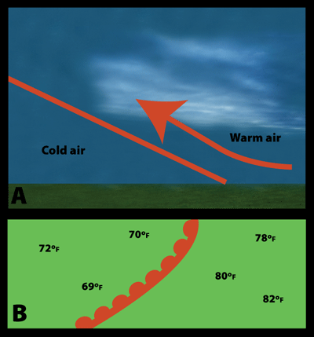

**Figure 4.** Diagram of a warm front. [1]

Warm fronts tend to form wedge-like shapes as it is hard for the light air to push the cold air, and as a result of this interaction, the visible product of the front is usually a low but increasing layer of clouds and rain. The process behind this movement of the warm air over the cold is called *frontal lifting*. Rain usually forms before and during the approach of the boundary layer (the point on the ground where the two fronts meet).

**Stationary Fronts**

A stationary front is a situation that occurs when neither the colder or hotter air mass has enough energy to push into the other (therefore forming either a cold or warm front). Instead, they sit in a stalemate that will only break if the wind changes direction causing the formation of a warm or cold front, or the disintegration of the front completely.

**Occluded Fronts**

The final category of fronts that we will discuss is called Occluded fronts. They are the most complex of the four. Because cold fronts are denser, and therefore carry more momentum and speed, they will sometimes catch up to a warm front and overtake it, making contact with the cold air mass in the warm front. As we mentioned before, warm fronts are shaped like a wedge with the warm air moving into and above the colder air. An occluded front is when a cold front will push into the back of the warm wedge and make contact with the cold air in front. The result of this interaction is usually precipitation from high altitude clouds as well as a general drying of the air (a direct result of the colder air mass pushing the warmer up above itself).

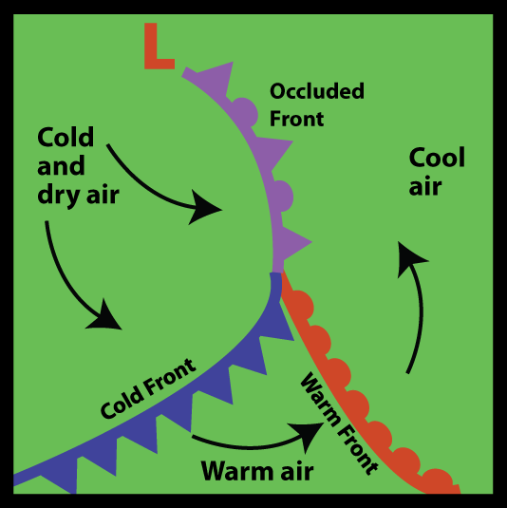

**Fig 5.** A pictographic representation showing the result of a cold front catching a warm front and creating an occluded front. [1]

There is no *usual* shape which occluded fronts take, but they can be recognized by the lifting of clouds, and appearance of precipitation, the cooling or warming of the air, and the clearance of the skies all taking place at the same time.

1. **Now it’s your turn to create your own weather front. In this experiment, we were simulating a cold front using water (they are in the atmosphere). How might you create your own front using a similar setup to the previous one? Begin by resetting the tank and emptying all of the used water onto a thirsty plant.**

| **Setup (explain what water you used, salty? Hot? cold?)** | **Drawing and description of the result** |
| --- | --- |
| **Hollow cylinder : ____________**  **Main tank : _________________** |  |

**Glossary**

* Stratocumulus Cloud
  + A large low-level group of clouds is usually observed to be in the shape of long blunt edges.
* Centrifugal Force
  + The force on a spinning object parallel to its instantaneous direction of motion

**Examples**

**References**

1. <https://scied.ucar.edu/learning-zone/how-weather-works/weather-fronts>
2. <https://pixabay.com/photos/storm-storm-front-cloud-front-1627683/?scrlybrkr=6b7c354f>
3. <http://weathertank.mit.edu/links/projects/fronts-an-introduction/fronts-tank-how-to>
4. <https://www.weather.gov/lmk/basic-fronts>
5. <https://www.livescience.com/39004-weather-fronts-definition-facts.html>
6. <https://www.azfamily.com/weather/phoenix_weather_blog/the-amazing-discovery-of-cold-fronts-100-years-ago/article_0caff3a9-974c-5082-bba9-748d2086b534.html>
7. <https://www.youtube.com/watch?v=wJF_EKTDqiI>
8. <https://cbsaustin.com/weather/weather-blog/freezing-rain-possible-behind-another-arctic-cold-front-this-week>